Competitor Research (Top 3 Competitors)
Based on leading digital marketing education brands in India:
- Digital Vidya
- Simplilearn
- NIIT Digital Marketing
Unique Selling Points (USPs)
- Advanced Digital Marketing + AI Curriculum
- 80% Practical, 20% Theory
- 100% Job Assistance + Paid Internship
- Global Certifications (Google/Semrush)
- 1:1 Doubt Solving + Dedicated Portal Campaign Setup
a) Selected Objective
Campaign Objective
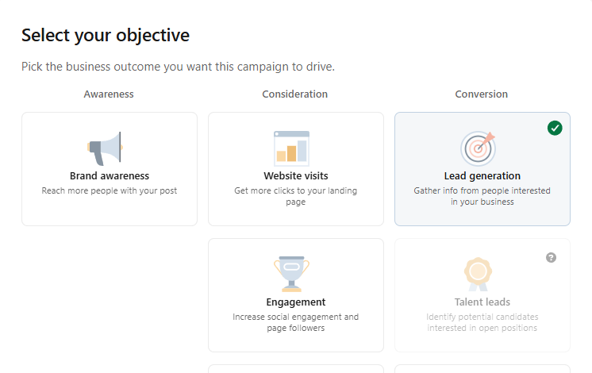
b) Budget Setup (Mock Screenshot Description)
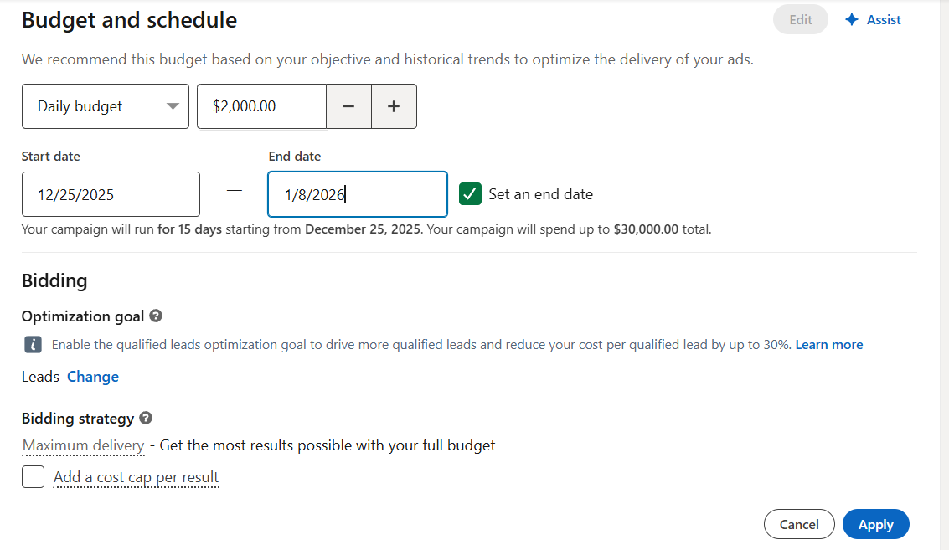 c) Audience Targeting (Mock Screenshot Representation)
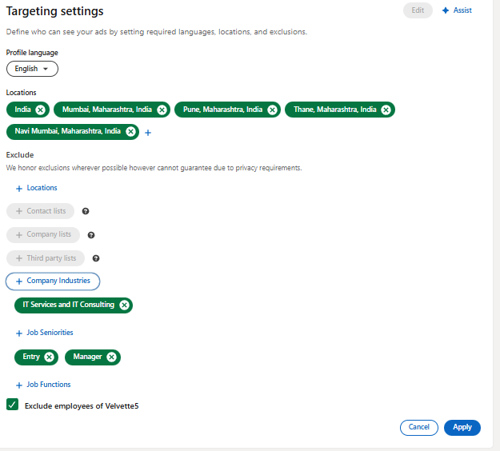
d) Ad Preview
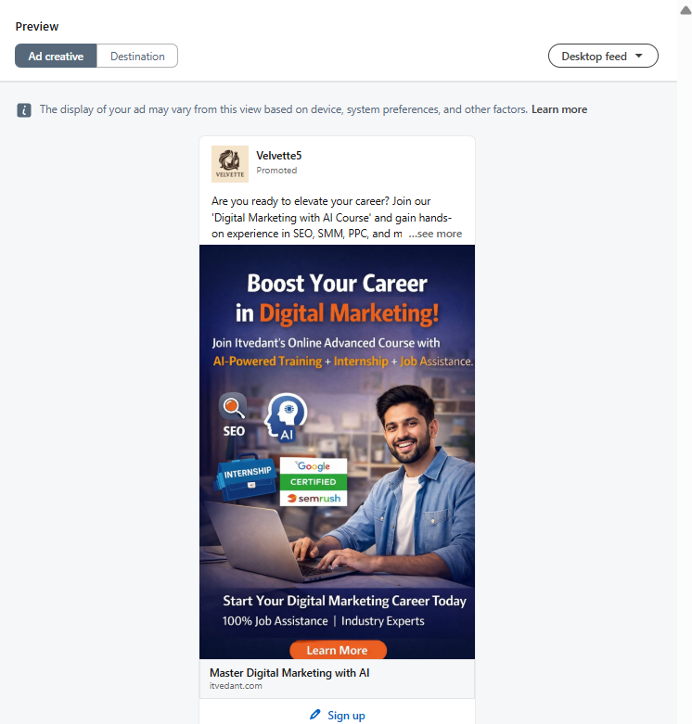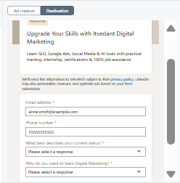
e) Estimated Campaign Results

